Holidays

You do an important role, so it’s important that you take your holiday and have time to relax and re-charge your batteries. FitzRoy’s Annual Leave starts on 30 days! Increases to 32 days after just 2 years’ service and we give you another day when you reach 5 years. Our leave year runs from 1st April until 31st March, so if you join after the 1st April or work part time hours, your annual leave will be calculated to reflect this.


Holiday Top-Up Scheme

You can apply to purchase up to 1 weeks’ annual leave. Should your application be accepted, deductions will be made direct from your salary over a period of 12 months and will commence in the April of the new holiday year.

To be eligible you must have passed your probationary period before the start of the annual leave year. Application forms will be available each year prior to the start of the annual leave year.

Blue Light Card
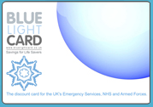
If you purchase a Blue Light Card (£4.99 for 2 years) FitzRoy will reimburse you. A Blue Light Card provides those in the NHS, emergency services, social care sector and armed forces with discounts online and in-store. Register for your card at bluelightcard.co.uk and reclaim the cost through expenses.

HSF Health Plan

We have invested in a scheme for you to claim back cash that you spend on health care such as the opticians, dentists, chiropractor and many, many, more. When you pass your probation you will be automatically enrolled to this scheme and you will received a welcome pack from HSF and an invite to attend a presentation about how the scheme works.




Perkbox

Along with your welcome pack from HSF about your Health Care Cash plan membership, you will be given free access to Perkbox! Yes, you can have both your Blue Light Card and your Perkbox membership to maximise your savings!

Perkbox not only gives you savings at hundreds of shops, it also includes social activities such as the cinema and gym memberships and you’ll even find complete freebies!

Tempted? Here’s some well-known brands you’ll find in your Perkbox to tempt you further.



HSF Assist

With your HSF Health plan you’ll also be given access to HSF Assist. This provides you with a variety of assistance helplines and services:

  - GP telephone advice – 24-hour access to a doctor
  - Virtual Doctor - a webcam based face-to-face consultation service with a doctor
  - Counselling service - a telephone and, if needs be, a face-to-face counselling service
  - Legal helpline - telephone access to solicitors and barristers

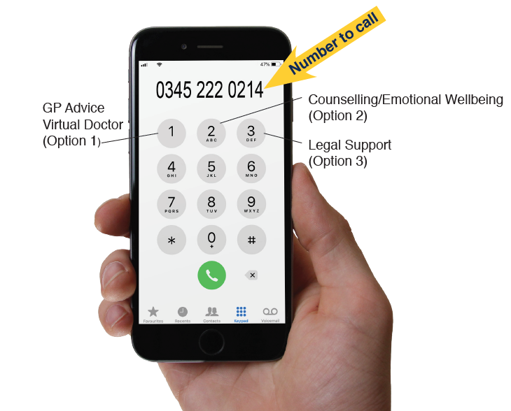

How to contact HSF Assist

Bike to Work
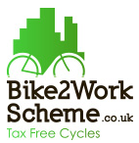
With our cycle to work scheme, we will pay for a bike or cycle equipment up front, giving you the opportunity to pay back the loan over 12 or 24 months. As payments are taken you’re your salary before tax and NI the scheme offers a more affordable way to pay for your bike and keeping fit! This benefit becomes available when you pass your probation.

Recommend a Friend


Love working for FitzRoy? Recommend your friends to work here too! If you do and they get the job, then we will pay you £150 on their start date and £150 when they complete their probation period.

We Celebrate your Success!

We love to share your success stories every Friday with the whole of FitzRoy and in the world of social media. If a story from your service gets published, your team will be considered for Team of the Month. Winners will make headline news in our Team Brief and a prize delivered to the service.

Loyalty Awards

We want our staff to have long and enjoyable careers with us. We value and appreciate those who commit and are loyal to FitzRoy and the People we Support. As a thank you we celebrate continuous service date milestones with the following bonus payments:
- 10 years - £125  - 15 years - £150  - 20 years - £200  - 25 years - £250  - 30 years - £300 | - 35 years - £350  - 40 years - £400  - 45 years - £450  - 50 years - £500

All cash gifts are subject to tax and NI under HMRC guidelines.

Pensions

With your contract, you will receive information about the pension schemes FitzRoy has on offer. You will know from this information that you may be auto enrolled into a pension scheme and you will have details on how you can ‘Opt-Out’.

Life Assurance

We all worry about how we will provide for loved ones and dependents if the worst happens. To make sure that staff know they will still be able to support their families in the sad event of their death, we provide life assurance cover at no cost to staff up to your 75th birthday. All staff can nominate who should receive a sum at one times your basic salary.

Training and Development

As part of our commitment to developing staff your training and development needs will be discussed regularly in Support and Development meetings and they will be annually assessed as part of the appraisal process. Speak to your manager about what training is available or discuss any specific training and development needs that you have.

